DOS & DON’TS
SPECIAL PRE-PLE MOCK 2025

24TH JULY, 2025
MATHEMATICS
Time Allowed: 2 hours 30 minutes
Random No. |  |  |  |  |  | Personal No.

Candidate’s Name……………………………………………………………………….
Signature……………………………………………………..………………………........
School Name: …………………………………………………..…………………………
Read the following instructions carefully:
FOR EXAMINERS’ USE ONLY
QN NO. | MARKS | EXR’S  NO.
1 - 5
6 - 10
11- 15
16 - 20
21- 22
23 - 24
25 - 26
27- 28
29 - 30
31 - 32
TOTAL
1. This paper has two sections: A and B.
Section A has 20 questions and section
B has 12 questions.

2. Answer all the questions. All the working for
both sections A and B must be shown in the
spaces provided.

3. All the working must be done using a blue or
black ball point pen or ink. Any work done in
Pencil other than graphs and diagrams will
Not be marked.

4. No calculators are allowed in the examination
Room.

5. Unnecessary changes in your work
and handwriting that cannot be read easily may lead to loss of marks.

6. Do not fill anything in the table indicated
“FOR EXAMINERS’ USE ONLY” and in the
boxes inside the question paper.

TURN OVER

SECTION: A (40 MARKS)

1. Divide: 90 $÷$ 6

2. Write “Twenty four thousand ninety one” in figures.

3. Find the GCF of 18 and 30.

4. Given set R $=$ a, p, e , list down all the proper subsets of set R.

5. Using a pair of compasses, a sharp pencil and a ruler only, construct an angle of 75⁰.

6. Subtract (3h$-$5m) from (4h$-$4m) .

7. Find a fraction equivalent to $\frac{3}{4}$

8. Without dividing, state whether 2304 is exactly divisible by 3.

9. Okello started his journey at 10:20a.m. and covered a distance of 140km. If he completed his journey at 12:20p.m at what speed was he moving?

10. Find the average of 4k$-$6, 3k, 4 and 5k$+$10.

11. Work out (9.48 $÷$ 4) $+$ (2.52 $÷$ 4) using distributive property.

12. If a die is tossed once, what is the probability of getting an Even number?

13. Round off 49897 to the nearest hundreds.

14. What integer is five steps to the left of 3?

15. Express 150,000kg as tonnes.

16. The distance around the figure below is 25cm. Find its radius. (Take $π$ $=$ $\frac{22}{7}$ )

17. Two angles 2R +40⁰ and 110⁰ are supplementary. Find the value of R.

18. Namayanja bought 1 ½ litres of cooking oil at sh.6000 a litre. How much did she pay for cooking oil she bought?

19. Work out 42 – 21 ÷3.

20. Given the coordinate graph below. Study and use it to answer the questions that follow. Y-axis
+4
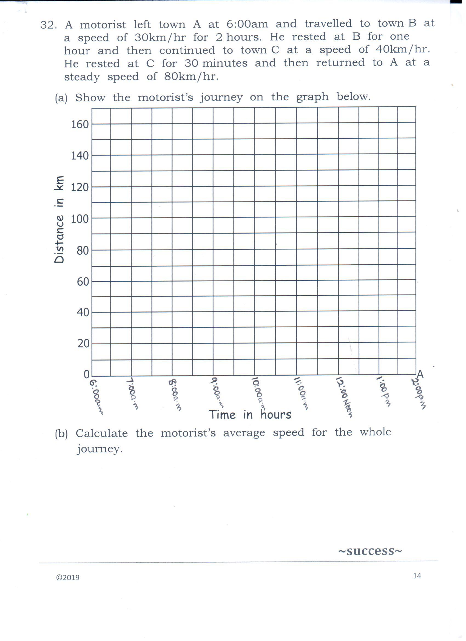
x-axis
+4
+3
+2
+1
+1
+2
+3
M
0
1
3
2
2
3
1
4

(i) Plot point K( 3 , ⁺4)

(ii) Write the coordinates of point M.

SECTION B (60 MARKS)
21. In class of 50 pupils, 32 play football (F), 23 plays Tennis (T), ‘X’ play both Football and Tennis, while 4 pupils do not play any of the two games.
a) Complete the Venn diagram below using the information given.
……….
n(F)=32
n(T)=23
4
……….
X
n(Σ)= 50
(02 marks)

(b) Find then value of X. (02 marks)

(c) How many pupils play one game? (2 marks)

22. Mr. Mukula, the District Education Officer of a certain district distributed 45 boxes of textbooks to all the primary schools in his district. If each box had 350 textbooks,
(a) find the total number of textbooks distributed by Mr. Mukula. (2 marks)

(b) If there are 75 primary schools in the district, find the equal number of textbooks each school got. (2 marks)

23. The figure below is a rectangle. Use the information on it to answer the questions that follow
(X- 1) cm
(3X - 2) cm
(X +8) cm

- Find the value of x. (02 marks)

- Find the area of the rectangle. (03marks)

24. Mutesi went shopping and bought the items shown in the table below.
ITEM | QUANTITY | UNIT COST | TOTAL COST
RICE | 3kg | Shs.4,300 per kg | Shs.__________
SUGAR | 1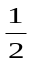kg | Shs.4,600 each kg | Shs.__________
SOAP | _____bars | Shs.3,500 a bar | Shs.7,000
SALT | 500gm | Shs.___________a kg | Shs.1,800
T O T A L E X P E N D I T U R E |  |  | Shs.__________
Complete the above table. (05marks)

25 Akumu drove from town A to town B at a speed of 60km/hr for 2 hours and from town B to town C at a speed of 150km/hr for 3 hours.
a) Find the total distance from town to A town C in km (03marks)

(b) Find Akumu’s average speed for the whole journey. (02marks)

26. Given the number 63,847 ;
(a) Expand the above number using powers of ten. (2 marks)

(b) Work out the quotient of the value of 6 and the value of 4 in the above number. (3 marks)

27(a) Using a ruler, a sharp pencil and a pair of compasses only, construct triangle KTV where KT $=$ 7cm, angles KTV= 90⁰ and TKV= 30⁰ .(4 mks)

(b) Measure angle KVT (1 mark @)

28. The table below represents the scores of Primary Six pupils in an
examination.
Marks scored | 50 | 60 | 40 | 90
Number of pupils | 4 | 3 | 2 | 1
(a) How many pupils did the test? (02 marks)

(b) How many pupils altogether scored less than 60 marks? (01mark)

(c) Work out the total mark scored by all the pupils (02marks)

29. The ratio of Women to Men to the children in the village is 3:5:7 respectively. If there are 60 more Children than the women in the village, find the total number of all the people in the village. (05marks)

30. The Venn diagram below shows the prime factors of X and Y .
F_{y}
F_{x}
3₁

2₁

3₂

2₂

5₂

(a)Find the value of X (1mk) (b)Find the value of Y(1mk)

c) Find the LCM of X and Y (2mks) (d) Find the GCF of X and Y(1mk)

31. The diagram below shows a big box 40cm long, 30cm wide and 25cm high and a small box 4cm by 4cm by 4cm. Study it carefully and answer the questions that follow
40cm
30cm
25cm
Big box
4cm
4cm
4cm
Small box

If such small boxes are to be packed into the big box;
(i) Find the number of small boxes that will be packed in the first layer of the big box? (02marks)

(ii) How many layers will fill the big box? (01mark)

(iii) How many small boxes will fill the big box? (02marks)

32. The circle graph below shows how Mzee Tegule distributed his 108 acres of land. Use it to answer the questions that follow.

Cash crops
Food crops

110⁰
K
60⁰
Pasture
Buildings

(a) Find the value of K. (2 marks)

(b) If he allocated 30 acres of land to buildings, how much land does Mzee Tefule own? (2 marks)

(c) Express the sector for pasture as a percentage. (1 mark)

